**Workshop Karnaugh maps**

**Julián Santiago Flórez Castañeda**

$ABC+\overline{A}C$

$$Simplified Expression:$$

$$BC+\overline{A}C$$

|  |  |  |  |
| --- | --- | --- | --- |
| **A** | **B** | **C** | **X** |
| 0 | 0 | 0 | 0 |
| 0 | 0 | 1 | 1 |
| 0 | 1 | 0 | 0 |
| 0 | 1 | 1 | 1 |
| 1 | 0 | 0 | 0 |
| 1 | 0 | 1 | 0 |
| 1 | 1 | 0 | 0 |
| 1 | 1 | 1 | 1 |

|  |  |  |
| --- | --- | --- |
| **Q** | **R** | **X** |
| 0 | 0 | 0 |
| 0 | 1 | 1 |
| 1 | 0 | 1 |
| 1 | 1 | 0 |

|  |  |  |  |
| --- | --- | --- | --- |
| **A** | **B** | **C** | **X** |
| 0 | 0 | 0 | 1 |
| 0 | 0 | 1 | 1 |
| 0 | 1 | 0 | 1 |
| 0 | 1 | 1 | 1 |
| 1 | 0 | 0 | 0 |
| 1 | 0 | 1 | 1 |
| 1 | 1 | 0 | 0 |
| 1 | 1 | 1 | 1 |

|  |  |  |  |
| --- | --- | --- | --- |
| **R** | **S** | **T** | **X** |
| 0 | 0 | 0 | 1 |
| 0 | 0 | 1 | 0 |
| 0 | 1 | 0 | 0 |
| 0 | 1 | 1 | 0 |
| 1 | 0 | 0 | 0 |
| 1 | 0 | 1 | 0 |
| 1 | 1 | 0 | 0 |
| 1 | 1 | 1 | 0 |

|  |  |  |  |
| --- | --- | --- | --- |
| **A** | **B** | **C** | **X** |
| 0 | 0 | 0 | 1 |
| 0 | 0 | 1 | 0 |
| 0 | 1 | 0 | 0 |
| 0 | 1 | 1 | 1 |
| 1 | 0 | 0 | 1 |
| 1 | 0 | 1 | 1 |
| 1 | 1 | 0 | 0 |
| 1 | 1 | 1 | 1 |

|  |  |  |  |
| --- | --- | --- | --- |
| **A** | **B** | **C** | **X** |
| 0 | 0 | 0 | 1 |
| 0 | 0 | 1 | 0 |
| 0 | 1 | 0 | 0 |
| 0 | 1 | 1 | 1 |
| 1 | 0 | 0 | 1 |
| 1 | 0 | 1 | 1 |
| 1 | 1 | 0 | 0 |
| 1 | 1 | 1 | 1 |

|  |  |  |  |  |
| --- | --- | --- | --- | --- |
| **A** | **B** | **C** | **D** | **X** |
| 0 | 0 | 0 | 0 | 1 |
| 0 | 0 | 0 | 1 | 0 |
| 0 | 0 | 1 | 0 | 1 |
| 0 | 0 | 1 | 1 | 1 |
| 0 | 1 | 0 | 0 | 1 |
| 0 | 1 | 0 | 1 | 0 |
| 0 | 1 | 1 | 0 | 1 |
| 0 | 1 | 1 | 1 | 0 |
| 1 | 0 | 0 | 0 | 1 |
| 1 | 0 | 0 | 1 | 1 |
| 1 | 0 | 1 | 0 | 1 |
| 1 | 0 | 1 | 1 | 0 |
| 1 | 1 | 0 | 0 | 1 |
| 1 | 1 | 0 | 1 | 0 |
| 1 | 1 | 1 | 0 | 1 |
| 1 | 1 | 1 | 1 | 0 |

|  |  |  |  |  |
| --- | --- | --- | --- | --- |
| **A** | **B** | **C** | **D** | **X** |
| 0 | 0 | 0 | 0 | 1 |
| 0 | 0 | 0 | 1 | 1 |
| 0 | 0 | 1 | 0 | 0 |
| 0 | 0 | 1 | 1 | 0 |
| 0 | 1 | 0 | 0 | 0 |
| 0 | 1 | 0 | 1 | 1 |
| 0 | 1 | 1 | 0 | 0 |
| 0 | 1 | 1 | 1 | 1 |
| 1 | 0 | 0 | 0 | 0 |
| 1 | 0 | 0 | 1 | 0 |
| 1 | 0 | 1 | 0 | 0 |
| 1 | 0 | 1 | 1 | 0 |
| 1 | 1 | 0 | 0 | 1 |
| 1 | 1 | 0 | 1 | 0 |
| 1 | 1 | 1 | 0 | 1 |
| 1 | 1 | 1 | 1 | 1 |

2) 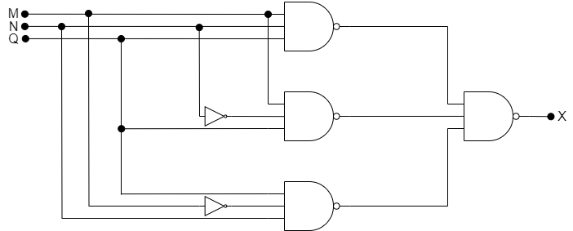

|  |  |  |  |
| --- | --- | --- | --- |
| **M** | **N** | **Q** | **X** |
| 0 | 0 | 0 | 0 |
| 0 | 0 | 1 | 0 |
| 0 | 1 | 0 | 0 |
| 0 | 1 | 1 | 1 |
| 1 | 0 | 0 | 0 |
| 1 | 0 | 1 | 1 |
| 1 | 1 | 0 | 0 |
| 1 | 1 | 1 | 1 |

|  |  |  |  |  |
| --- | --- | --- | --- | --- |
|  |  |  |  |  |
|  | 0 | 1 | 1 | 0 |
| $$\overline{M}$$ | 0 | 0 | 1 | 0 |

$$X=\left(MQ\right)+(NQ)$$

3)

|  |  |  |  |
| --- | --- | --- | --- |
| **A** | **B** | **C** | **X** |
| 0 | 0 | 0 | 1 |
| 0 | 0 | 1 | 0 |
| 0 | 1 | 0 | 1 |
| 0 | 1 | 1 | 1 |
| 1 | 0 | 0 | 1 |
| 1 | 0 | 1 | 0 |
| 1 | 1 | 0 | 0 |
| 1 | 1 | 1 | 1 |

|  |  |  |  |  |
| --- | --- | --- | --- | --- |
|  |  |  |  |  |
|  | 1 | 0 | 1 | 0 |
| $$\overline{A}$$ | 1 | 0 | 1 | 1 |

$$X=BC+\overline{B}\overline{C}+\overline{A}B$$

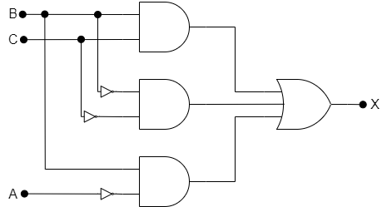

4)

|  |  |  |  |  |
| --- | --- | --- | --- | --- |
| $$A_{3}$$ | $$A_{2}$$ | $$A_{1}$$ | $$A_{0}$$ | $$X$$ |
| 0 | 0 | 0 | 0 | 0 |
| 0 | 0 | 0 | 1 | 0 |
| 0 | 0 | 1 | 0 | 0 |
| 0 | 0 | 1 | 1 | 1 |
| 0 | 1 | 0 | 0 | 1 |
| 0 | 1 | 0 | 1 | 1 |
| 0 | 1 | 1 | 0 | 1 |
| 0 | 1 | 1 | 1 | 1 |
| 1 | 0 | 0 | 0 | 0 |
| 1 | 0 | 0 | 1 | 0 |
| 1 | 0 | 1 | 0 | 0 |
| 1 | 0 | 1 | 1 | 0 |
| 1 | 1 | 0 | 0 | 0 |
| 1 | 1 | 0 | 1 | 0 |
| 1 | 1 | 1 | 0 | 0 |
| 1 | 1 | 1 | 1 | 0 |

|  |  |  |  |  |
| --- | --- | --- | --- | --- |
|  |  |  |  |  |
|  | 0 | 1 | 0 | 0 |
| $$\overline{A_{1}}{ A}_{0}$$ | 0 | 1 | 0 | 0 |
| $$A_{1}{ A}_{0}$$ | 1 | 1 | 0 | 0 |
|  | 0 | 1 | 0 | 0 |

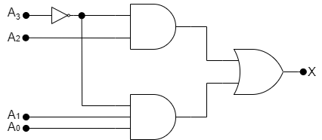

5) a)

|  |  |  |  |  |
| --- | --- | --- | --- | --- |
|  |  |  |  |  |
| 0 | 0 | 0 | 0 | 0 |
| 0 | 0 | 0 | 1 | 0 |
| 0 | 0 | 1 | 0 | 1 |
| 0 | 0 | 1 | 1 | 1 |
| 0 | 1 | 0 | 0 | 0 |
| 0 | 1 | 0 | 1 | 0 |
| 0 | 1 | 1 | 0 | 0 |
| 0 | 1 | 1 | 1 | 0 |
| 1 | 0 | 0 | 0 | 0 |
| 1 | 0 | 0 | 1 | 1 |
| 1 | 0 | 1 | 0 | X |
| 1 | 0 | 1 | 1 | X |
| 1 | 1 | 0 | 0 | X |
| 1 | 1 | 0 | 1 | X |
| 1 | 1 | 1 | 0 | X |
| 1 | 1 | 1 | 1 | x |

|  |  |  |  |  |
| --- | --- | --- | --- | --- |
|  |  |  |  |  |
|  | 0 | 0 | 0 | 0 |
| $$\overline{B}A$$ | 0 | 0 | 1 | 1 |
| $$BA$$ | 1 | 0 | 1 | 1 |
| $$B \overline{A}$$ | 1 | 0 | 0 | 0 |

$$X=\left(\overline{D} \overline{C} B\right)+(A D)$$

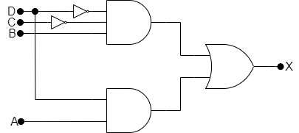

b)

|  |  |  |  |  |
| --- | --- | --- | --- | --- |
| $$D$$ | $$C$$ | $$B$$ | $$A$$ | $$X$$ |
| 0 | 0 | 0 | 0 | 0 |
| 0 | 0 | 0 | 1 | 0 |
| 0 | 0 | 1 | 0 | 0 |
| 0 | 0 | 1 | 1 | 1 |
| 0 | 1 | 0 | 0 | 1 |
| 0 | 1 | 0 | 1 | 1 |
| 0 | 1 | 1 | 0 | 0 |
| 0 | 1 | 1 | 1 | 0 |
| 1 | 0 | 0 | 0 | 1 |
| 1 | 0 | 0 | 1 | 0 |
| 1 | 0 | 1 | 0 | X |
| 1 | 0 | 1 | 1 | X |
| 1 | 1 | 0 | 0 | X |
| 1 | 1 | 0 | 1 | X |
| 1 | 1 | 1 | 0 | X |
| 1 | 1 | 1 | 1 | x |

|  |  |  |  |  |
| --- | --- | --- | --- | --- |
|  |  |  |  |  |
|  | 0 | 1 | 1 | 1 |
| $$\overline{B}A$$ | 0 | 1 | 0 | 0 |
| $$BA$$ | 1 | 0 | 0 | 1 |
| $$B \overline{A}$$ | 0 | 0 | 1 | 1 |

$$X=\left(BA\overline{C}\right)+\left(\overline{D}C\overline{B}\right)+(D\overline{A})$$

